Index.html
<!DOCTYPE html>
<html lang="en">
<head>
<meta charset="UTF-8">
<meta http-equiv="X-UA-Compatible" content="IE=edge">
<meta name="viewport" content="width=device-width, initial-scale=1.0">
<title>Document</title>
<link rel="stylesheet" href="style.css">
</head>
<body>
<div class="container">
<div class="c1"> <p>Lorem ipsum dolor sit amet consectetur adipisicing elit. Amet incidunt, minima reiciendis error, adipisci debitis nam, facilis delectus dicta nulla aut animi dolores natus fugiat obcaecati cum quo nesciunt itaque.</p></div>
<div class="c2"><p> Lorem ipsum dolor sit amet consectetur adipisicing elit. Repellat explicabo incidunt beatae fugiat nihil ea corporis ratione aliquam odit, enim magnam dolorem quae neque quasi ipsam nobis officia. Qui, minima. Lorem ipsum dolor sit amet consectetur adipisicing elit. Ipsa facere quaerat soluta voluptatibus id illum dolorum voluptates earum laborum aperiam suscipit atque asperiores ad accusamus alias et, architecto, minus libero.</p></div>
<div class="c3"><p>Lorem, ipsum dolor sit amet consectetur adipisicing elit. Iure modi ipsum aspernatur atque deleniti quasi eveniet adipisci. Enim et possimus, accusantium beatae tempora veniam deserunt, neque aliquam, cupiditate optio in?</p></div>
</div>
</body>
</html>

Style.css
.container{
display: flex;
/* width: 100%; */
/* padding: 5%; */
background-color: brown;
justify-content: center;
align-items: center;
/* flex-direction: column-reverse; */
/* flex-wrap: wrap-reverse; */
}
.c1{
/* flex: 25%; */
/* order: 2; */

/* top: 0; */

background-color: pink;
}
.c2{
/* align-self: flex-start; */
/* align-self: flex-end; */
/* center baseline */
background-color: aquamarine;
}
.c3{
background-color: blueviolet;
}

@media only screen and (max-width: 600px) {
body {
background-color: rgb(102, 181, 207);
}
}

Class sir task
display flex
flex-direction
order
flex wrap
justify content
align items
flex proportion
align self

flex-direction: raw;
justify content x axis per
align items y axis

flex-direction: column;
justify content y axis per
align items x axis

flex-wrap

display flex main div class parent element per lgta ha
order means tarteeb

flex raw wise responsive krta han
grid column wise resposive krta han

POSITION : fix,absolute
static,sticky,fixed,relative,absolute

padding container ky andar ki space
margin webpage ki space

Read Cursor pg 347
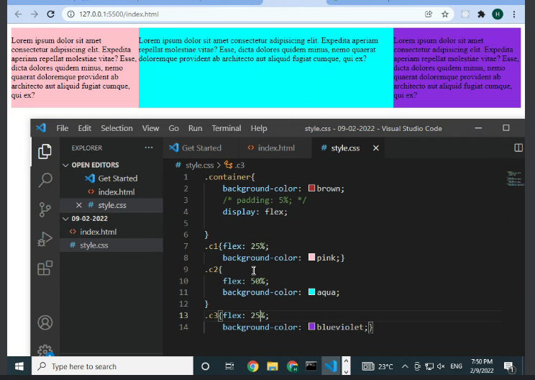
Asdss
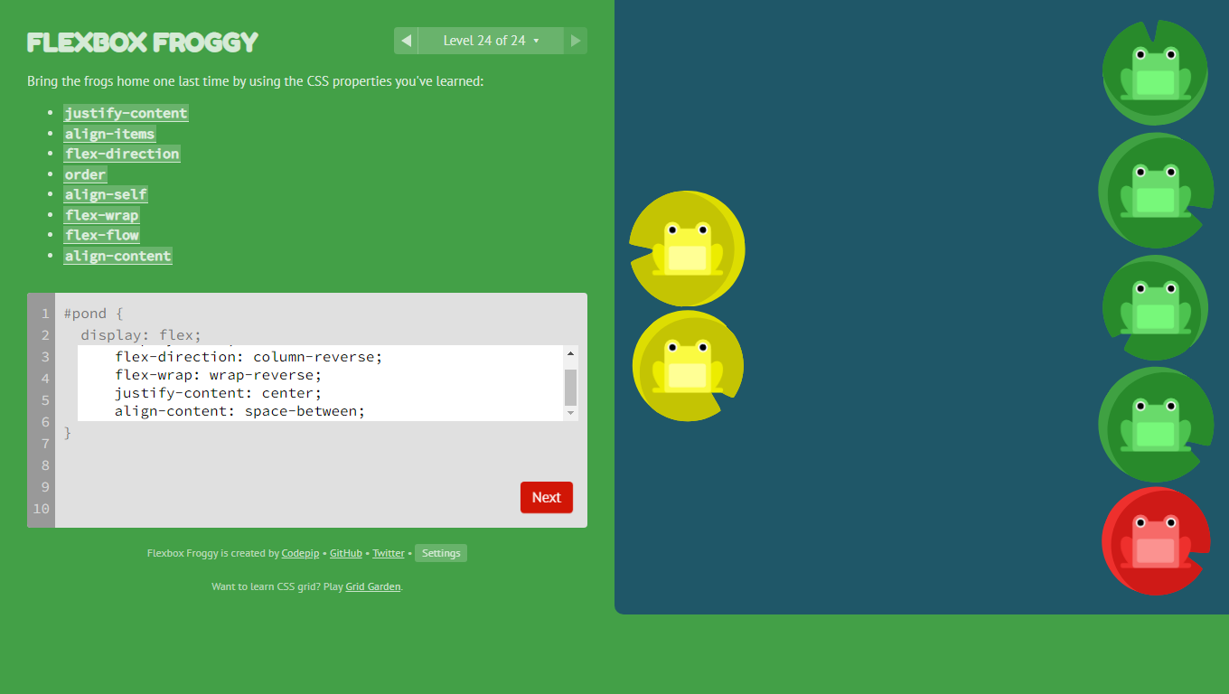

The position property specifies the type of positioning method used for an element.
There are five different position values:
- static
- relative
- fixed
- absolute
- sticky
This <div> element has position: static;
<head>
<style>
div.static {
position: static;
border: 3px solid #73AD21;
}
</style>
</head>
<body>

<h2>position: static;</h2>

<p>An element with position: static; is not positioned in any special way; it is always positioned according to the normal flow of the page:</p>

<div class="static">
This div element has position: static;
</div>
Sadsa
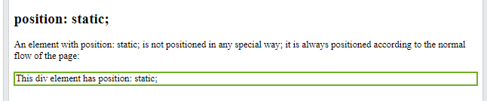

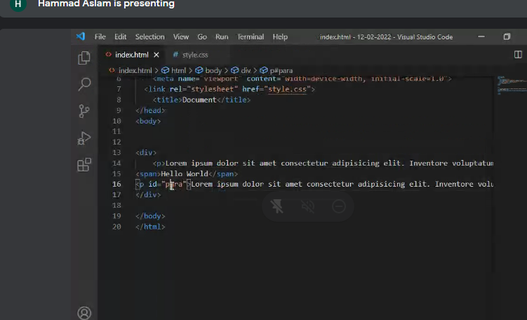
WHAT IS DIV?
Sir:
Jab Div ka koi child NHI hota toh uska koi container NHI hota jb uska child hoga phr ussy who uski height width control krta han DIV.

Koi b element container banata han.
Relative
Pos relative : left jiss sy who left sy move hojaye ga
Pos absolute:

The z-index property specifies the stack order of an element. Z-index only works on positioned elements (position: absolute, position: relative, position: fixed, or position: sticky) and flex items (elements that are direct children of display: flex elements).
z-index : sy Element ki importance bhar jati han

Read : fixed layout, liquid layout
Git
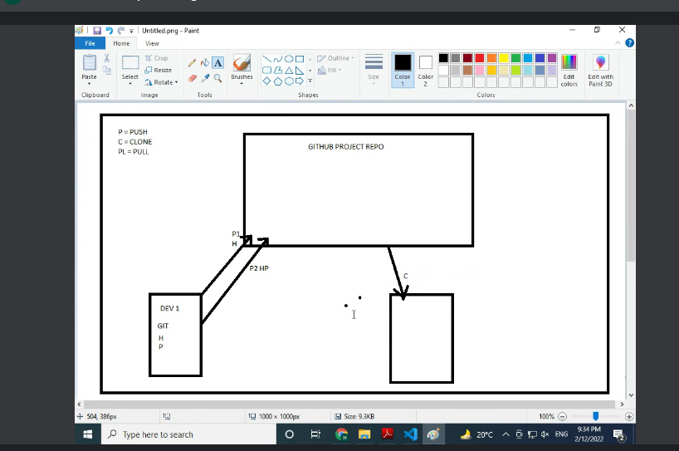
2
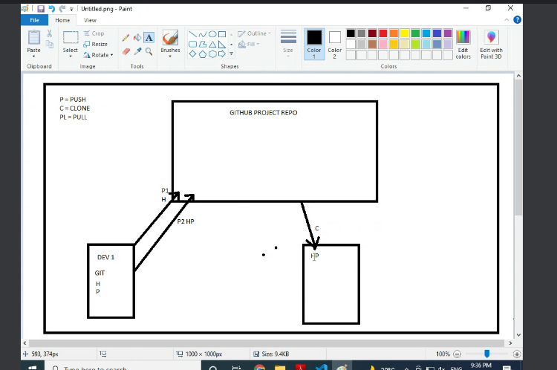
3
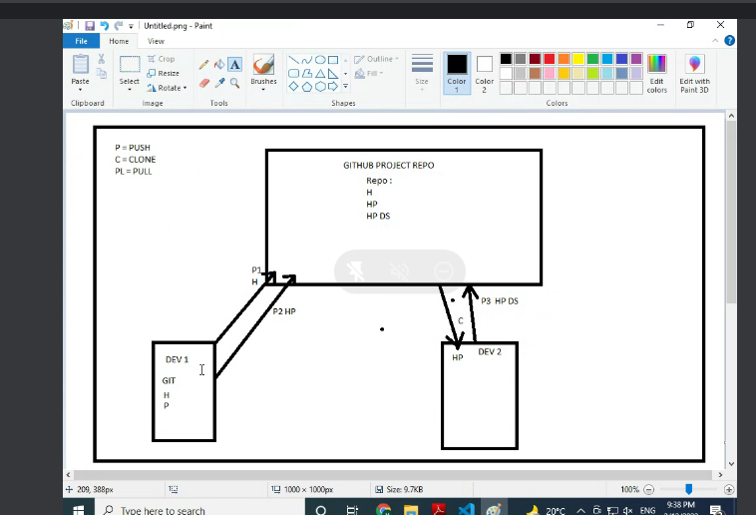
4
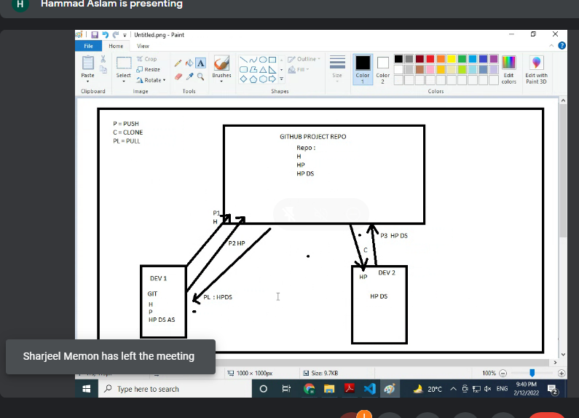
5
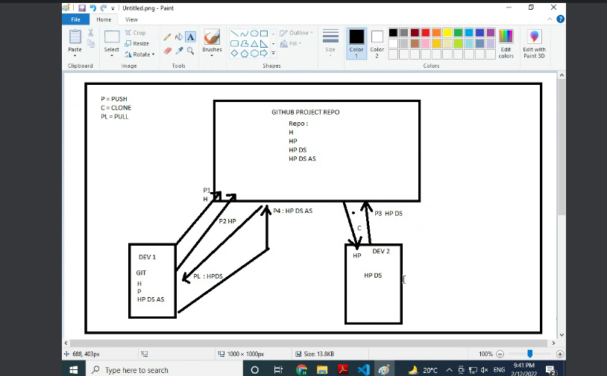
6
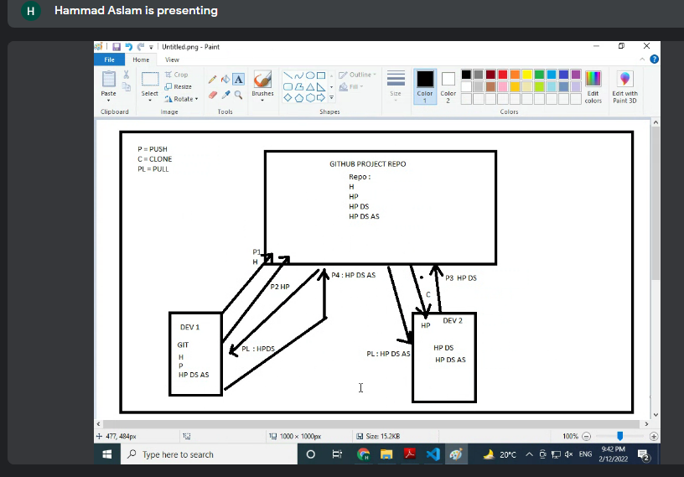
7
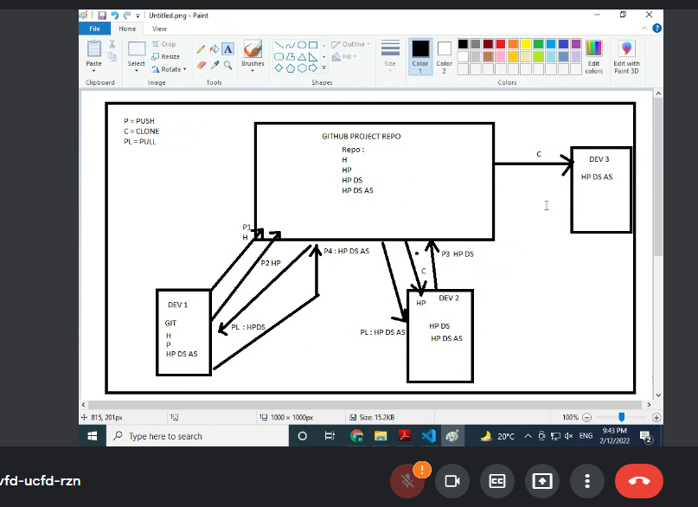
git init
git status
git add .
git commit -m "first commit"
git commit -m "class-Assignment"
>git status
git add . //For update code
git commit -m "class-Assignment-new"
git branch -M main //for only one time
git branch

git status
git remote add origin https://github.com/DanishArmy/Web-and-mobile-b4-module-A.git
git push -u origin main
git push origin main //sir

